Name: Syed Aazmir
Student ID: 24K-0945
Course: DLD Lab
Lab Number: Lab 10
Instructor: Ishtiaq Ahmed

Qs 1
SR Flip Flop
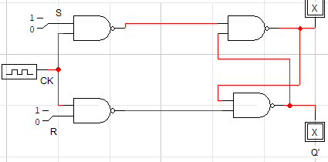

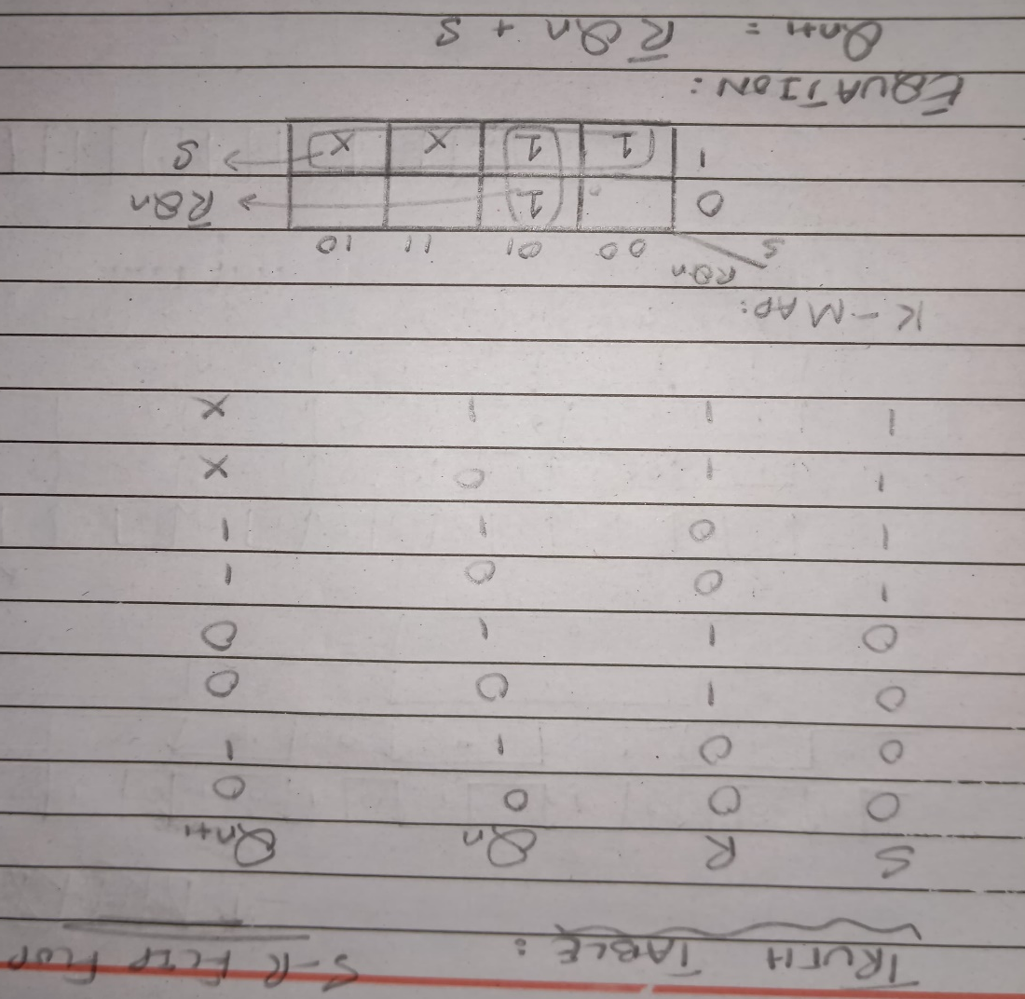

Qs 2
JK Flip Flop

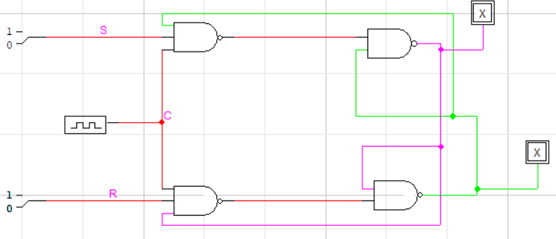

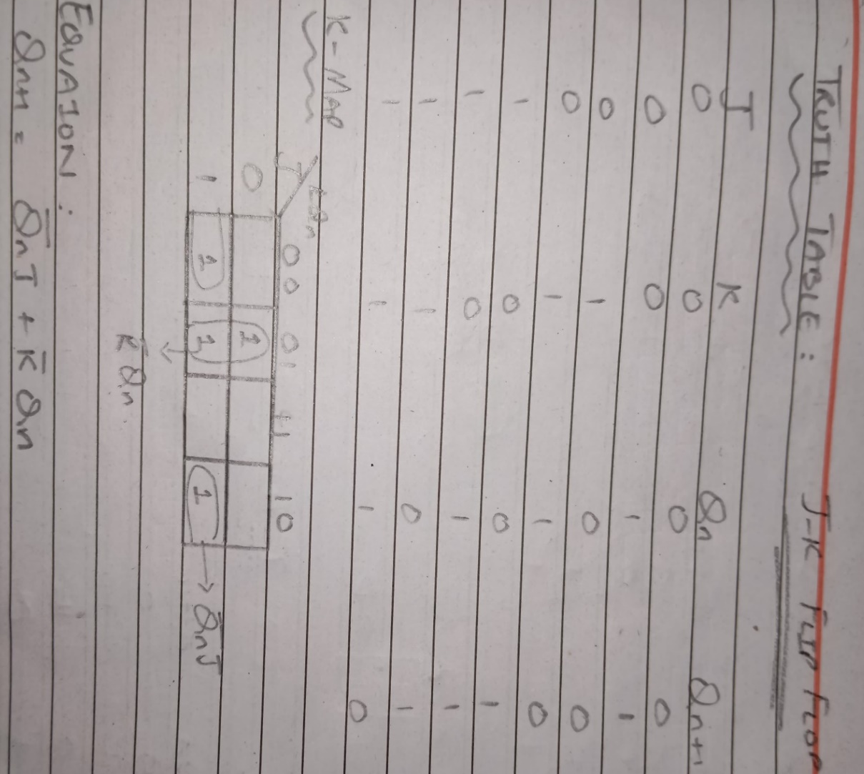

Qs 3
D Flip Flop

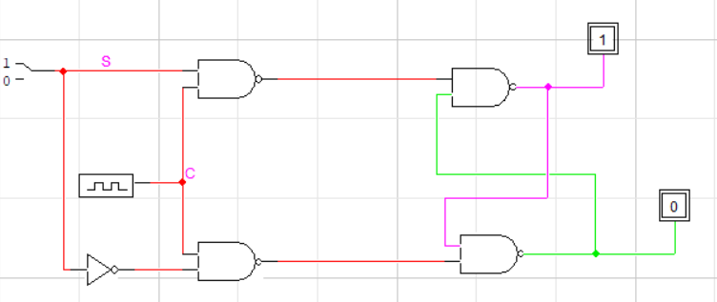

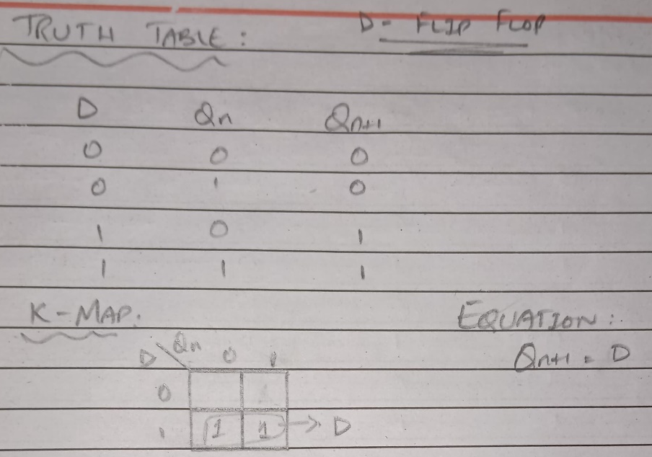

Qs 4
T Flip Flop

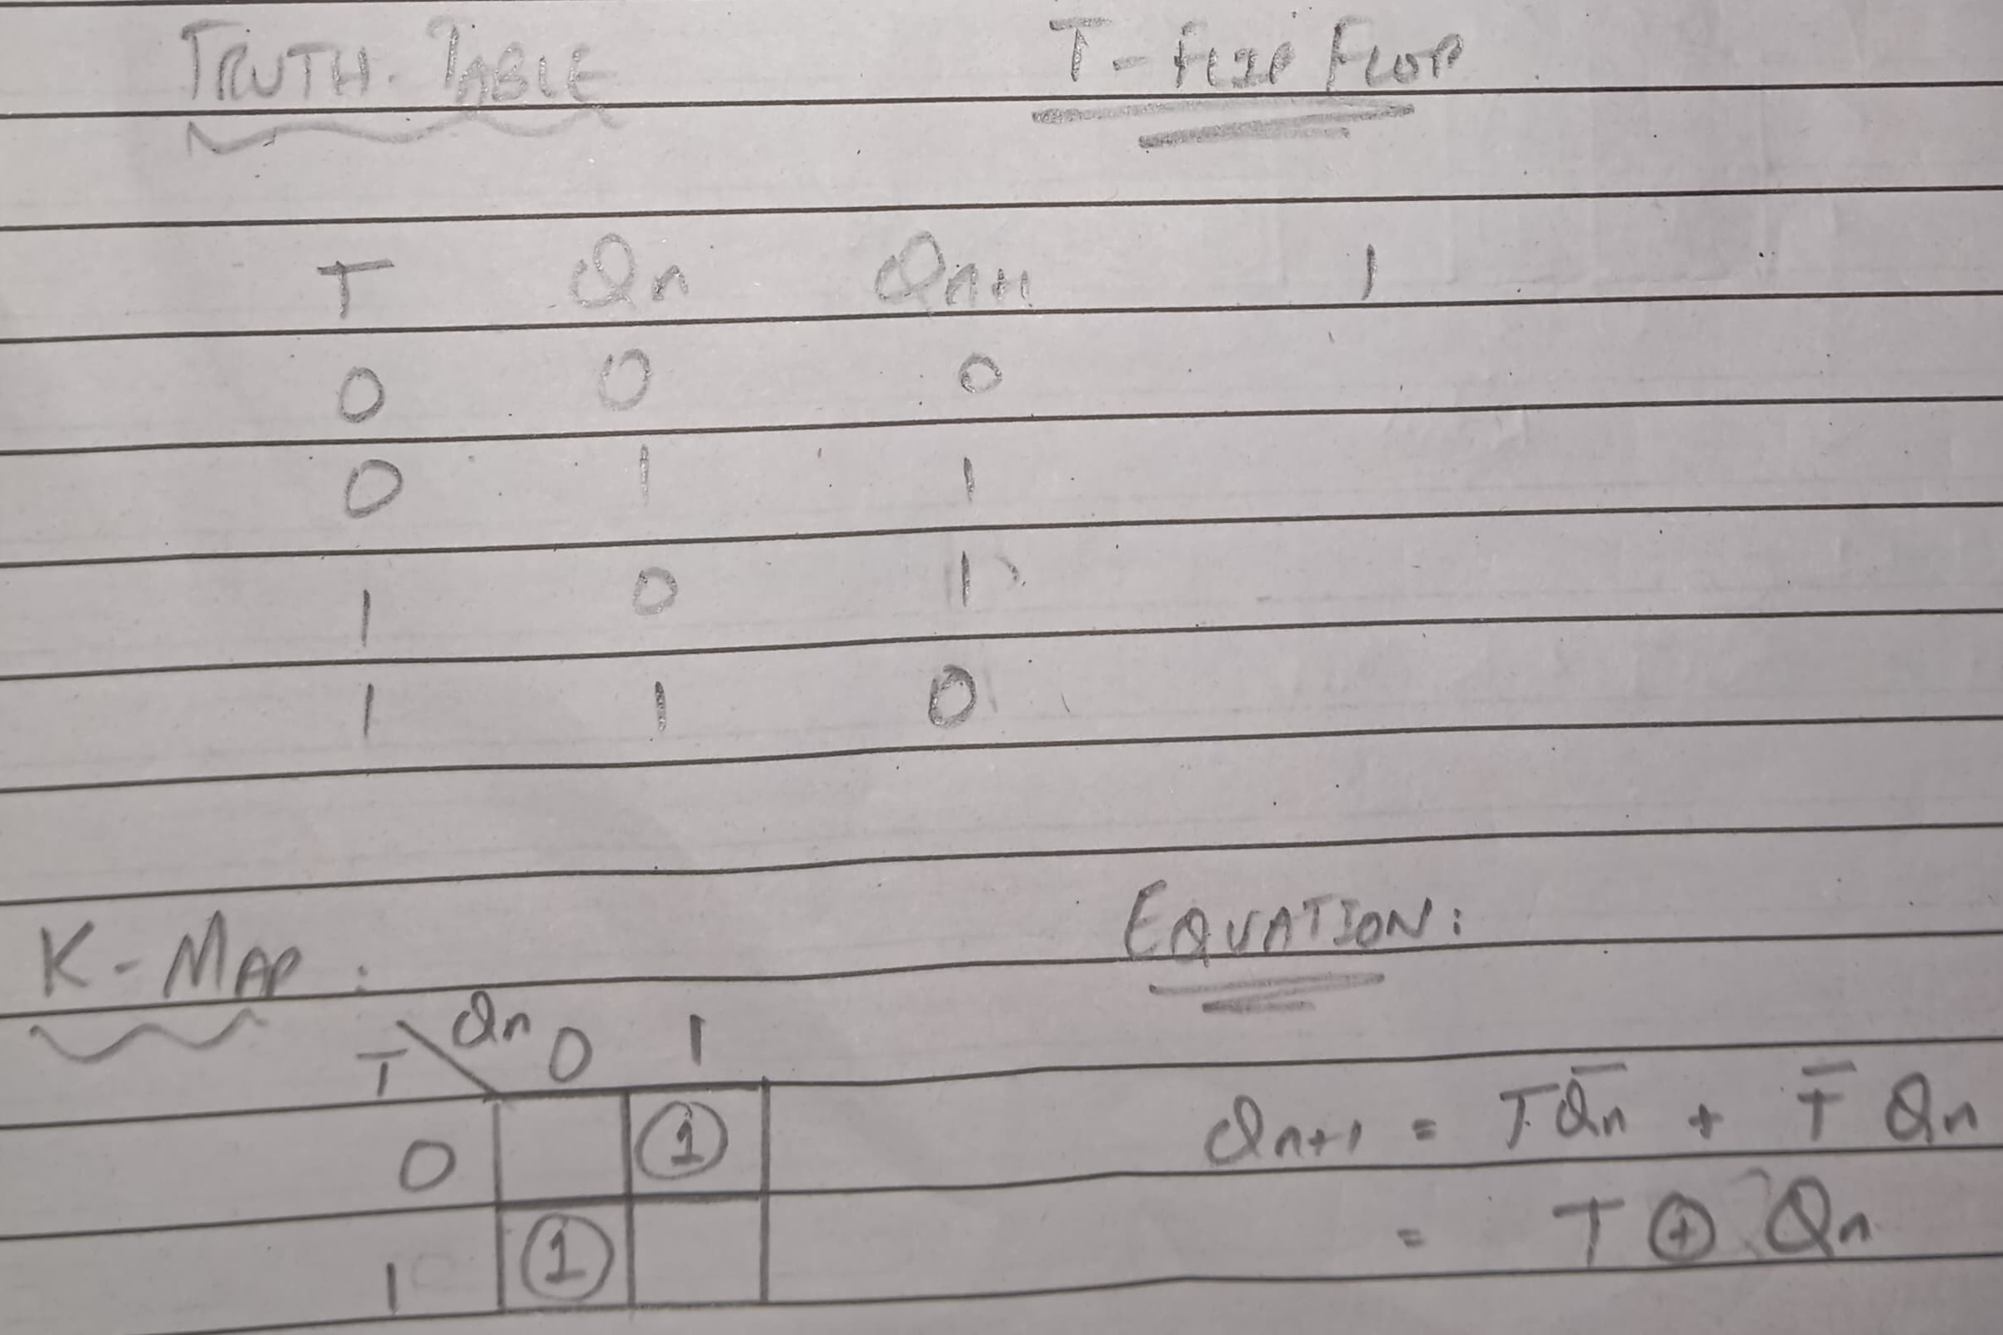
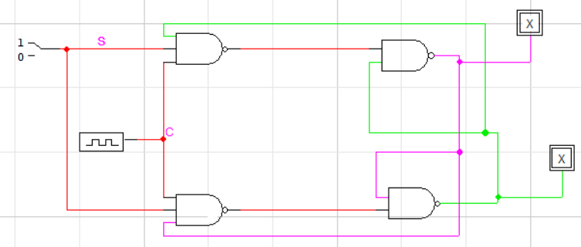

Qs 5
3 bit Up/DOWN Counter

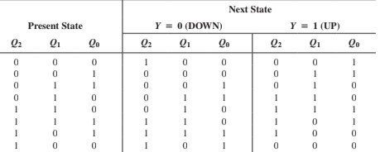
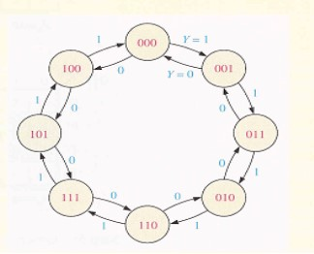

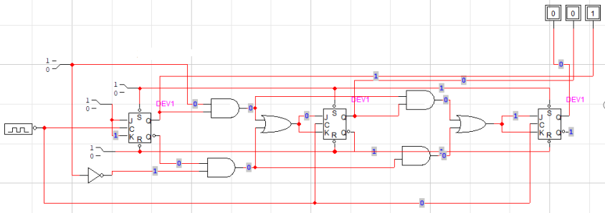

Qs 6
Design a binary counter to count 0-63 number

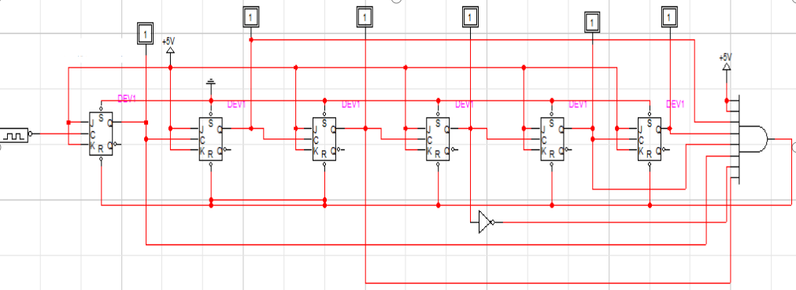

Qs 7
Implement a traffic signal with programmable counters (Set a value as how long the counter must count i.e. a 3 bit would only allow a timer of 16 seconds). Set a condition where if there are no cars present the lights should turn yellow and only turn on if any of the cars are present in at least two intersections. There should also be a pedestrian counter.

